 | 7.0.19 Editors - 3D Viewport - Armature - Edit Mode - Lattice context menu
Table of content
Edit Mode - Lattice Context Menu 1
Mirror 1
Interactive Mirror 1
X Global, Y Global etc. 1
Last Operator Mirror 1
Orientation 2
Constraint Axis 2
Proportional editing 2
Proportional Falloff 2
Proportional Size 2
Connected 2
Projected(2D) 2
Flip 2
Last Operator Flip (Distortion Free) 2
Flip Axis 2
Snap 2
Last Operator Snap 3
Offset 3
Make Regular 3

Edit Mode - Lattice Context Menu
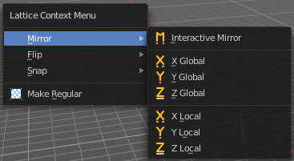
Call this menu with double right click in the 3D viewport. You need to be in Edit mode with a armature object.

Mirror
Mirror mirrors the selected geometry along the defined axis.

Interactive Mirror
Mirror by hotkeys. You activate the tool, type in x for x global for example, or x x for x local. And the selection gets mirrored.

X Global, Y Global etc.
Mirrors the selection around the chosen axis.

Last Operator Mirror

The Last Operator Mirror panel gives you tools to adjust the mirror action.


Orientation
Orientation is a drop-down box choose the type of orientation for the mirroring action.

Constraint Axis
Constraint Axis gives you again the possibility to define the mirror axis. You can choose more than one axis here.


Proportional editing
Enables proportional editing. Activating proportional editing reveals further settings.

Proportional Falloff
Adjust the falloff methods.

Proportional Size
See and adjust the falloff radius.

Connected
The proportional falloff gets calculated for connected parts only.

Projected(2D)
The proportional falloff gets calculated in the screen space. Depth doesn't play a role. When it's in the radius, then it gets calculated.

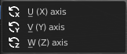
Flip
Flips the lattice object along the world axis X, Y or Z .

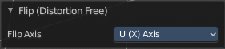
Last Operator Flip (Distortion Free)

Flip Axis
Flip the lattice object along the world axis X, Y or Z .


Snap
Choose several methods to snap one element to another. The menu items should be self explaining.

Last Operator Snap

Some snap operations shows a last operation panel, some not.

Offset
If the selection should snap as a whole, or if each individual element of the selection should snap.

Make Regular
Set the UVW control points by a uniform distance apart.

